1. 
2. 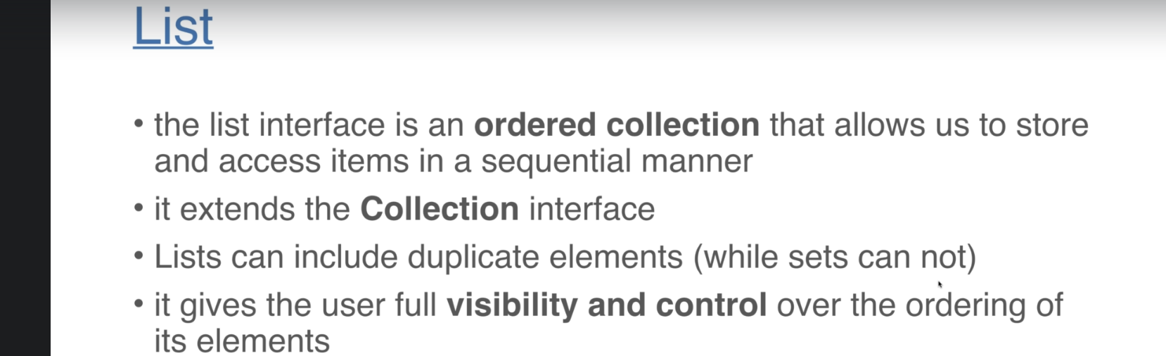
3. 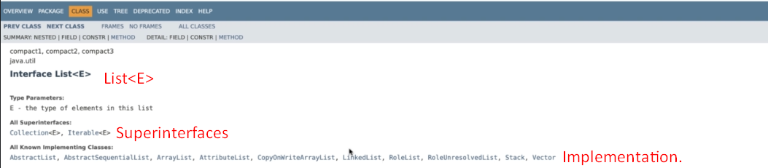
4. Use isEmpty() on list instead of list.size() == 0.